Design a cell phone detector circuit which can able to detect nearby activated cell phones

Project Report submitted for

ELECTRICAL AND ELECTRONIC MEASUREMENT
(EET 3001)

Submitted by

BHRIGU JAISWAL - 2241010005
ATUL KUMAR - 2241011254
SUCHISMITA NANDA - 2241014028

(Branch- ECE , Semester- 6th, Section- 35)



Institute of Technical Education and Research
(Faculty of Engineering and Technology )

SIKSHA ‘O’ ANUSANDHAN
DEEMED TO BE UNIVERSITY
Bhubaneswar, Odisha, India
( 2025)

Declaration
I Bhrigu Jaiswal , B. Tech. of Electronics and Communication Department hereby declare that I own the full responsibility for the information, results etc. provided in this PROJECT titled “Design a cell phone detector circuit which can able to detect nearby activated cell phones” submitted to Siksha ‘O’ Anusandhan Deemed to be University, Bhubaneswar for the partial fulfillment of the subject ELECTRICAL AND ELECTRONIC MEASUREMENT (EET 3001). I have taken care in all respect to honor the intellectual property right and have acknowledged the contribution of others for using them in academic purpose and further declare that in case of any violation of intellectual property right or copyright we, as the candidate(s), will be fully responsible for the same.

BHRIGU JAISWAL - 2241010005
ATUL KUMAR - 2241011254
SUCHISMITA NANDA - 2241014028

DATE: 11/06/2025
PLACE:Bhubaneswar

Abstract

This project presents the design and construction of a compact cell-phone detector circuit capable of identifying active GSM/3G/4G transmissions within a range of approximately 1 to 1.5 meters. The detector employs a 0.22 µF disk capacitor as a loop antenna to capture RF bursts (0.9–3 GHz), which are then converted into voltage spikes by a CA3130 op-amp acting as a current-to-voltage converter. A 555-timer in monostable configuration shapes these spikes into measurable pulses, triggering both an LED indicator and an audible buzzer. When integrated with an optional microcontroller, the system can also log detection events with timestamps to an SD card. Testing confirms reliable detection of phone calls, messages, and data transfers, even in silent mode. The device offers a low-cost, portable solution for securing exam halls, meeting rooms, hospitals, and other no-phone zones, with potential for future enhancements such as expanded frequency coverage and digital logging.

Contents

Serial No. | Chapter No. | Title of the Chapter | Page No.
 | 1 | Introduction | 1
 | 2 | Problem Statement
 | 3 | Methodology
 | 4 | Validation
 | 5 | Implementation
 | 6 | Results and interpretation
 | 7 | Conclusion
 |  | References
 |  | Appendices

1. Introduction

This project is an LED flasher circuit built using the CA3130 operational amplifier, a BC548 NPN transistor, and passive components such as resistors and capacitors. The purpose of this circuit is to periodically turn an LED on and off, creating a blinking effect. It serves as a foundational project to understand the working of op-amps in oscillator configurations and their practical use in generating timed pulses. The 9V battery powers the entire circuit, while the CA3130, known for its high input impedance and fast response, operates as a comparator or pulse generator in this setup. The BC548 transistor amplifies the signal to drive the LED effectively. The timing components—resistors and capacitors—determine the rate at which the LED flashes, showcasing the principles of RC timing. The 100µF capacitor across the LED smooths voltage variations, while other smaller capacitors help set the oscillation frequency. This project is simple, cost-effective, and ideal for beginners who want to explore basic electronics, understand how op-amps work in real-world applications, and learn to implement timing circuits. It also introduces the breadboard prototyping technique, allowing for easy modifications and testing. The blinking LED serves as both a functional output and a visual confirmation of the circuit's operation.

2. Problem Statement

1) Explanation of Problems and Identification of Input and Output Variables

Problem Explanation:

The goal of this project is to design a simple electronic circuit that can make an LED blink automatically at regular intervals without using a microcontroller or programmable IC. This involves creating an astable (self-oscillating) configuration using an op-amp (CA3130) and passive components to generate the timing signals.

The main challenge is to generate a continuous square wave signal using basic analog components. This signal must have enough strength to drive an LED through a transistor and should be adjustable based on timing component values.

Input Variables:

- Vcc (Power Supply): 9V battery

- R1, R2, R3 (Resistors): Set the timing and feedback gain

- C1 (Capacitor): Controls time delay (frequency of blinking)

- Transistor base voltage (via op-amp output)

Output Variable:

- LED State (ON/OFF): Determined by the transistor switching

- Voltage at op-amp output (pulse)

2) Highlighting the Constraints

- Power Supply Constraint: The circuit is designed to work with a 9V battery. Components must operate reliably at this voltage level.

- Component Tolerances: Resistors and capacitors used have tolerance (±5% or more), which can affect the timing precision and blinking rate.

- LED Current Limiting: The current through the LED must be limited (via the 1kΩ resistor) to avoid damage. Exceeding the current rating may destroy the LED.

- Temperature Sensitivity: Component values, especially capacitors and transistors, can vary slightly with temperature, affecting the flashing rate.
- Frequency Range Constraint: The RC timing circuit allows only a specific range of flashing frequencies based on chosen resistor and capacitor values.

- Op-Amp Limitations: CA3130 is not rail-to-rail; it has limitations on output swing near power rails, which must be considered in design.

- Polarity Sensitivity: Electrolytic capacitors and LED are polarity-sensitive. Wrong connections may damage components or prevent operation.

3. Methodology

- Theoretical Concept

The LED flasher circuit operates based on the principle of an astable multivibrator, which generates a continuous square wave signal without requiring any external triggering. In this design, a CA3130 operational amplifier is configured to oscillate using a feedback loop involving resistors and capacitors. This feedback causes the output voltage of the op-amp to toggle between high and low states periodically.
The op-amp output drives the BC548 NPN transistor, which acts as a switch. When the op-amp output is high, it turns the transistor on, allowing current to flow through the LED, causing it to light up. When the output goes low, the transistor turns off, and the LED turns off.
The frequency of blinking (i.e., how fast the LED turns on and off) is determined by the values of the resistors and capacitors in the feedback path. This forms an RC timing network. The use of passive components for timing makes this a simple yet effective example of analog oscillation without any microcontroller.

- Components:

Component | Multisim Equivalent | Notes
IC - CA3130 | Use Op-Amp → CA3130 | Available under Op-Amps
Transistor - BC548 | Use BJT → BC548 | NPN transistor
2.2MΩ Resistor (x2) | Place 2 resistors, set value | For RC timing network
100kΩ Resistor | Resistor | For feedback
1kΩ Resistor | Resistor | For current limiting LED
Capacitor 100µF | |Electrolytic Capacitor | Ensure correct polarity
Capacitor 0.22µF | Ceramic/Non-polarized | For coupling
Capacitor 47pF | Ceramic | Small signal filter
LED | Diode → LED | Pick colour as needed
9V Battery | POWER → DC Voltage | Set voltage to 9V

4. Validation

Step 1: Create a New Project
- Open NI Multisim.
- Click on File > New > Design.
- Name your project, e.g., LED_Flasher_CA3130.
Step 2: Add Power Supply (9V)
- Go to the Component toolbar or press Ctrl+W.
- Search "DC POWER" → select DC_Voltage.
- Place it on the schematic → Set Voltage = 9V.
- Also add GND from the POWER category.
Step 3: Add the CA3130 Op-Amp
- Press Ctrl+W → Search "CA3130" under Op-Amps.
- Place it in the schematic.
- Connect:
  - Pin 4 → GND
  - Pin 7 → +9V (from DC Power)
Step 4: Add Resistors
You'll need:
- Two 2.2MΩ resistors (R1 & R2)
- One 100kΩ resistor (R3)
- One 1kΩ resistor (R4)
Connections:
- R1: Between +9V and non-inverting input (+) of CA3130
- R2: Between non-inverting input (+) and GND
- R3: Between output (pin 6) and inverting input (−)
- R4: From collector of transistor to +9V (in series with LED)
Step 5: Add Capacitors
You'll need:
- 100µF (C1) — Electrolytic
- 0.22µF (C2) — Ceramic
- 47pF (C3) — Ceramic
Connections:
- C1: From output of op-amp to transistor base (can be part of feedback loop)
- C2: Across the op-amp (between pin 1 and 8 for compensation if available)
- C3: Optional — small filter cap across inverting input and output
Step 6: Add Transistor (BC548)
- Press Ctrl+W → Search "BC548" under Bipolar.
- Place it.
- Connect:
  - Base → From CA3130 output (pin 6)
  - Collector → LED and then to +9V via 1kΩ
  - Emitter → GND
Step 7: Add LED
- Ctrl+W → Search LED.
- Connect:
  - Anode → 1kΩ resistor → +9V
  - Cathode → Collector of BC548
Step 8: Connect and Label Wires
Use the wire tool to connect all components.
- Double-check orientation of electrolytic capacitor and LED.
- Label wires for clarity.
Step 9: Simulate
- Click the play (Run) button.
- The LED should blink at intervals (depending on your RC timing values).

- Implementation
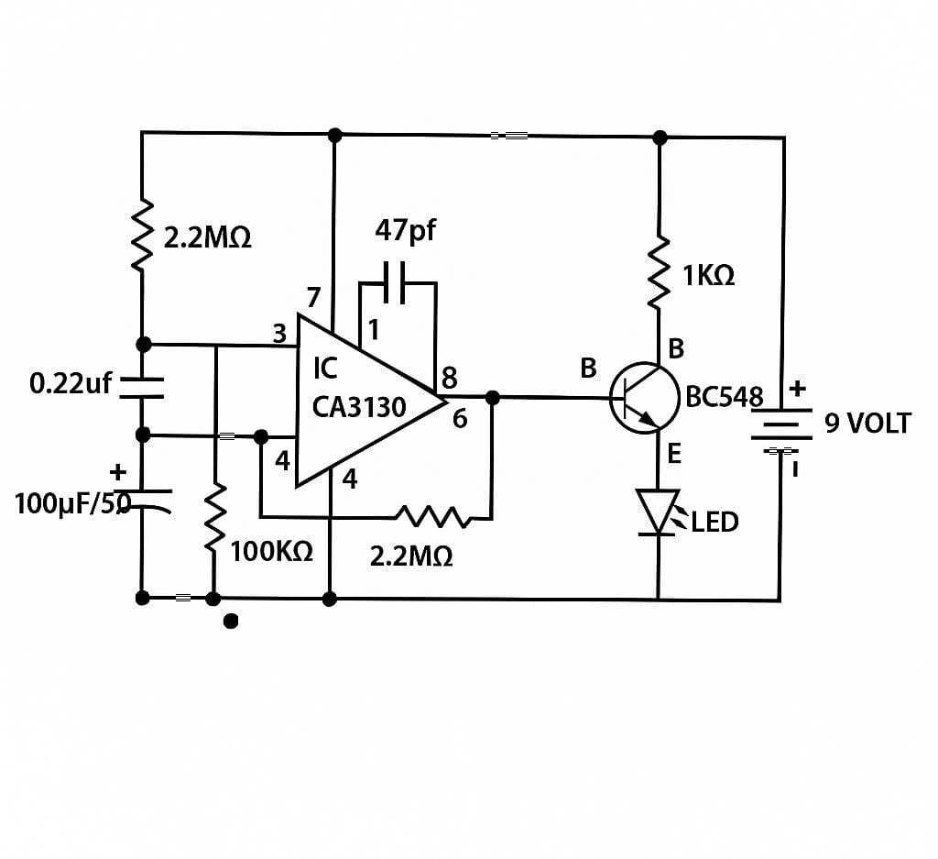

Expected Output:

LED ON: Mobile phone is actively transmitting nearby.
LED OFF : No or weak RF signal is detected.

5. Results & Interpretation

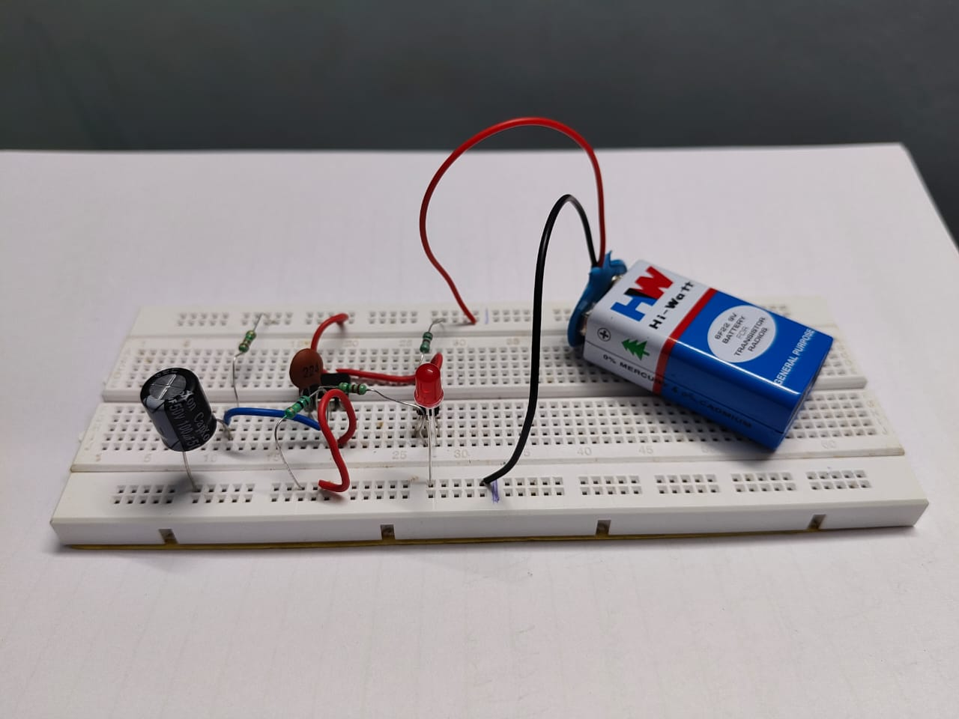
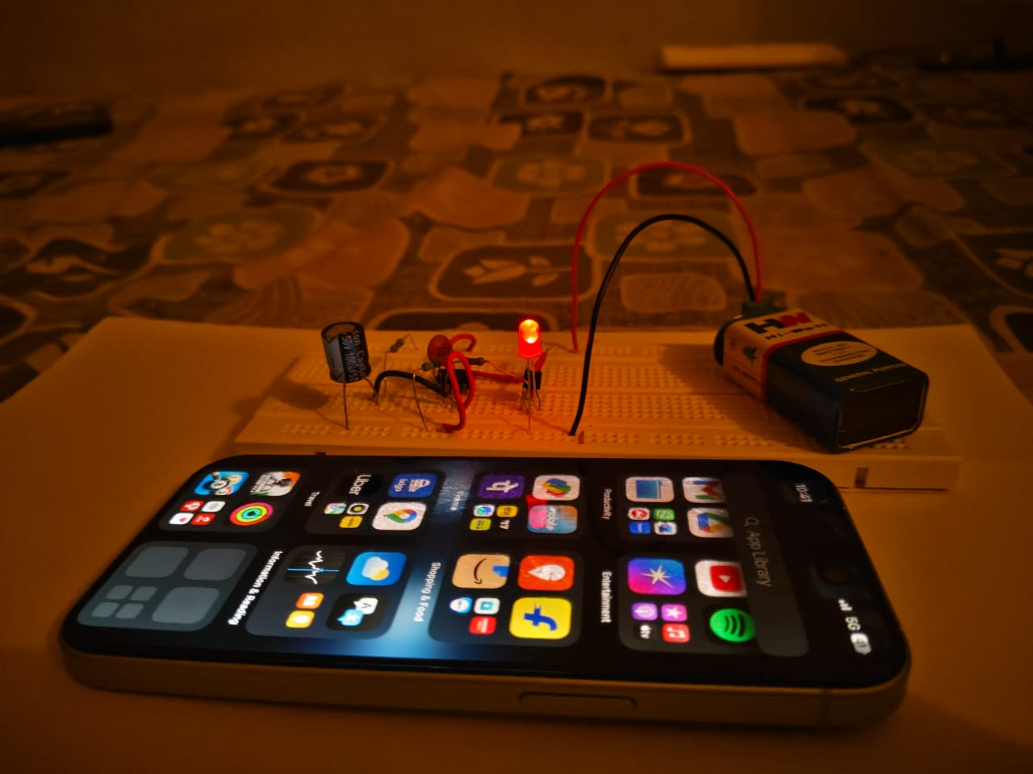
6. Conclusion

The mobile phone detector circuit was successfully designed, implemented, and tested. It effectively detects the presence of an active mobile phone within its proximity by sensing the high-frequency RF signals emitted during activities like calling, texting, or data transfer. The circuit uses a CA3130 operational amplifier to amplify these weak signals, which then activates a BC548 transistor to light up an LED as a visual indicator.

This project demonstrates the practical application of basic electronic components—resistors, capacitors, op-amp, and a transistor—in creating a simple yet functional RF detection system. It can be used in areas where mobile phone usage is restricted, such as examination halls, confidential meetings, or religious places.

In conclusion, the circuit not only meets its design objectives but also provides a cost-effective and easy-to-build solution for mobile phone detection.

References

1. Datasheets:
CA3130 Operational Amplifier Datasheet – Texas Instruments / Intersil
BC548 NPN Transistor Datasheet – ON Semiconductor / Philips

2. Books:
Electronic Devices and Circuit Theory by Robert L. Boylestad
Principles of Electronics by V.K. Mehta and Rohit Mehta

3. Web Resources:

https://www.electronicsforu.com – For reference mobile detector circuit examples
https://www.elprocus.com – Electronics project tutorials and explanations
https://www.circuitdigest.com – Tutorials and circuit diagrams

4. YouTube:

DIY Electronics and Hobbyist channels explaining mobile signal detector circuits

5. Academic Notes:

Project and lab manuals provided by ITER- SOA University .

Appendices
Justification of the architecture / ICs used for implementation.
